**Costs & Payments**

**Costs & Payments**

There are many costs to consider when a student goes to college or university both direct and indirect. Here you will find out what fees you're required to pay. Please be aware that all fees are subject to annual reviews and they may differ from year to year. Note, the fees outlined apply to academic year, 2022- 2023. Check back later in the year to view our updated fees for future academic year.   
  
**1- Tuition fees**  
All international students will pay tuition fees based on the degree they've chosen. The fees vary between degrees and the year in which you study. Tuition fee costs are subject to change and are determined each year and updated figures will be published on this page each academic year.  
 You can find the tuition fees (**USD**) for academic year 2022- 2023 in the table below.  
   
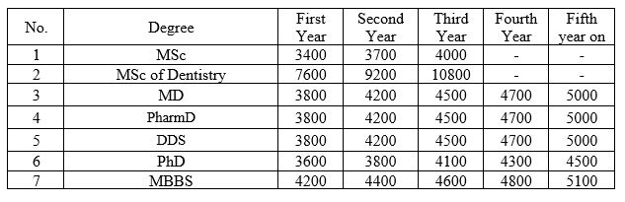  
  
  
**2- Insurance Fees**  
TUOMS requires that all registered international students carry adequate insurance coverage. To meet this requirement you will pay the insurance fees once and annually. You can find the monthly insurance fees (**IRR**) for academic year 2022- 2023 in the table below.  
  
  
  
**3- Accommodation Fees**  
TUOMS provides double rooms (meaning two beds in one room) for its international students. In a double room you have one roommate.  
The accommodation fee is paid once for a one academic year.

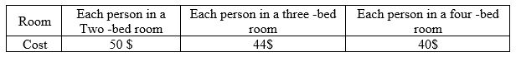

**4- Meal Costs**  
All students are required to pay for student meal plan. Payment for all meals is made by way of your university student card. To pay for your meals, you just swipe your student card for each meal. You can find the meal costs  
(IRR) for academic year 2022- 2023 in the table below.

|  |  |  |  |
| --- | --- | --- | --- |
| **Meal** | Breakfast (weekly) | Lunch  (daily) | Dinner (daily) |
| **Cost** | 4$ | 2$ | 2$ |

 